1. Define name range for birth rate and income group

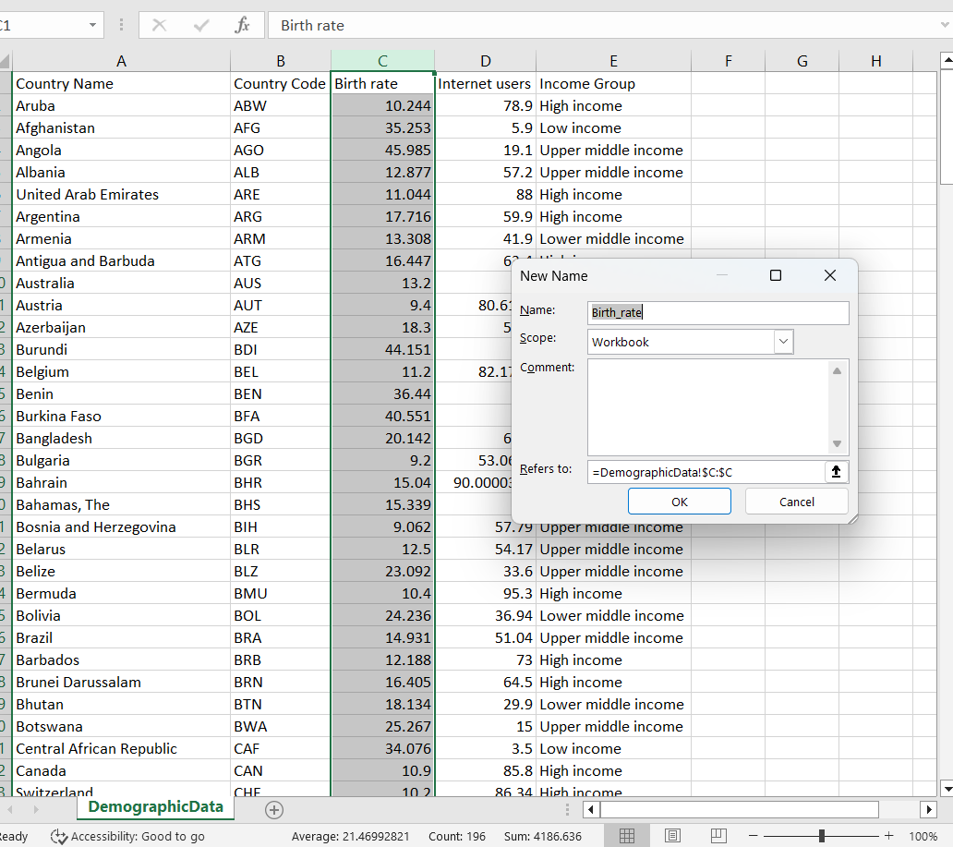

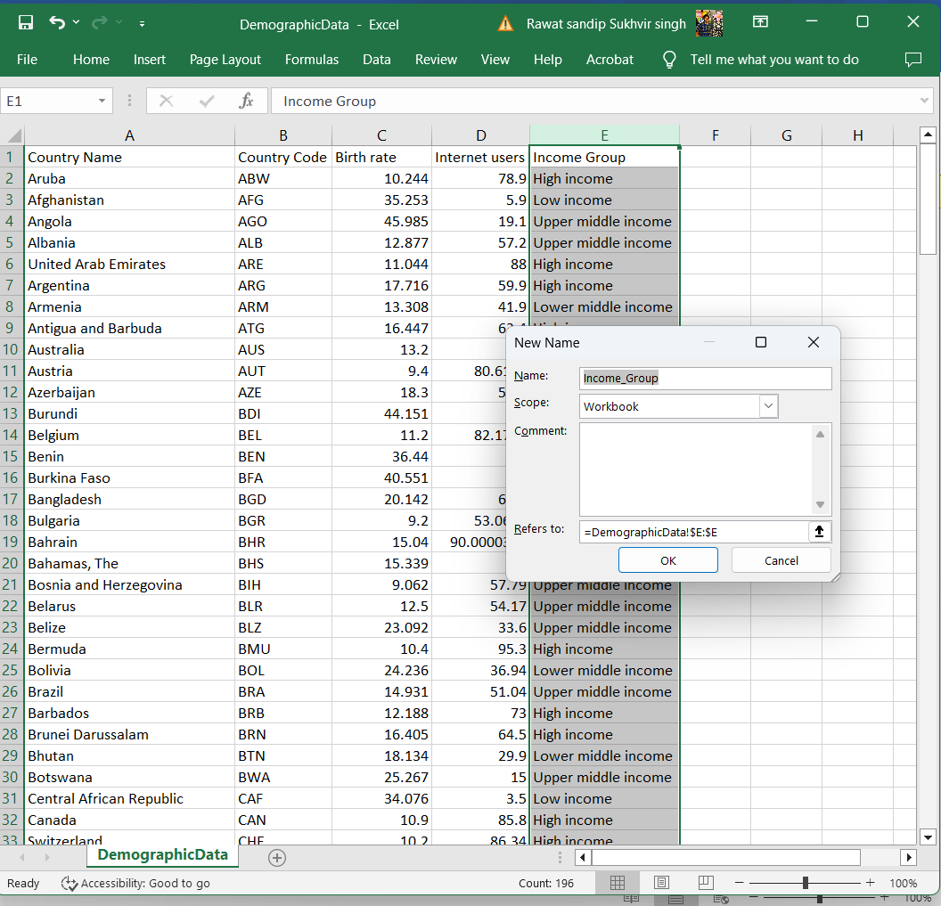

2. Calculate various statistical details:

* 1. Mean of birth rate and internet users.
  2. Median of birth rate and internet users.
  3. Variance of birth rate and internet users (consider both the population and sample variances).
  4. Standard deviation of birth rate and internet users (consider both the population and sample standard deviations).
  5. IQR of birth rate and internet users.

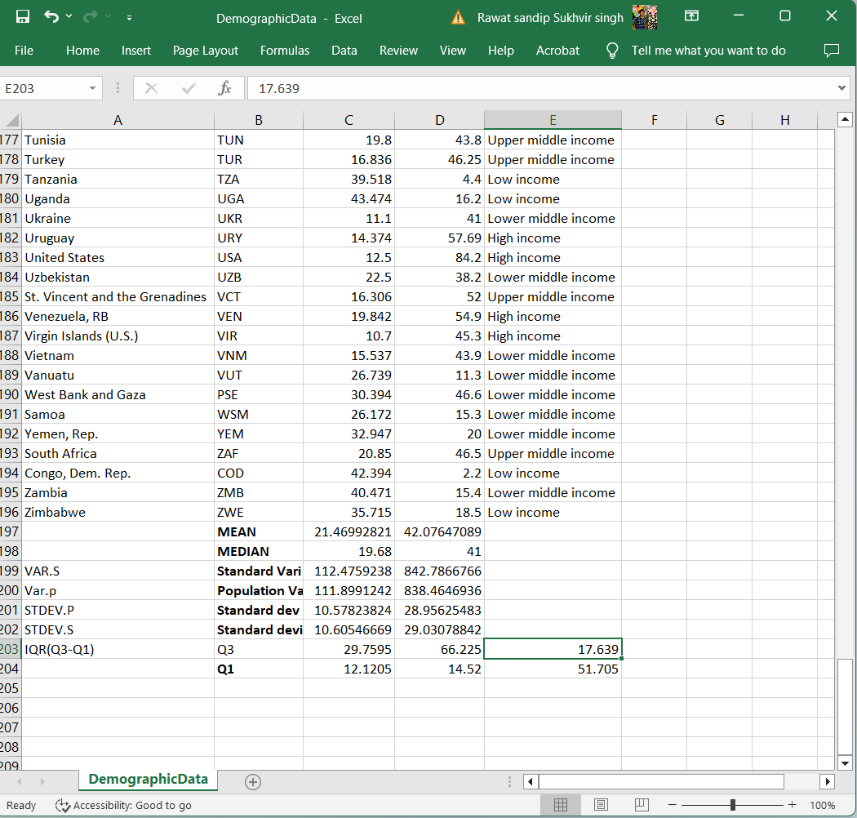

3.Create filters on country and income groups:

* 1. Use the country filter and check which income group India falls under.
  2. Filter all the countries of the same income group as India and take the count of countries.

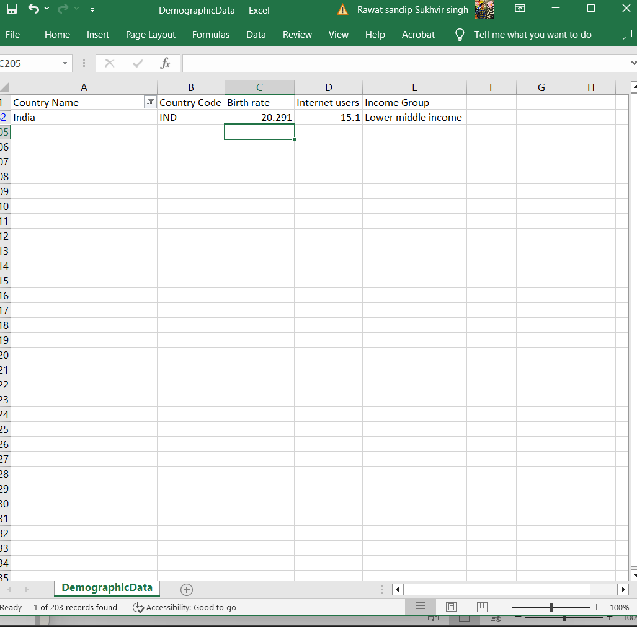

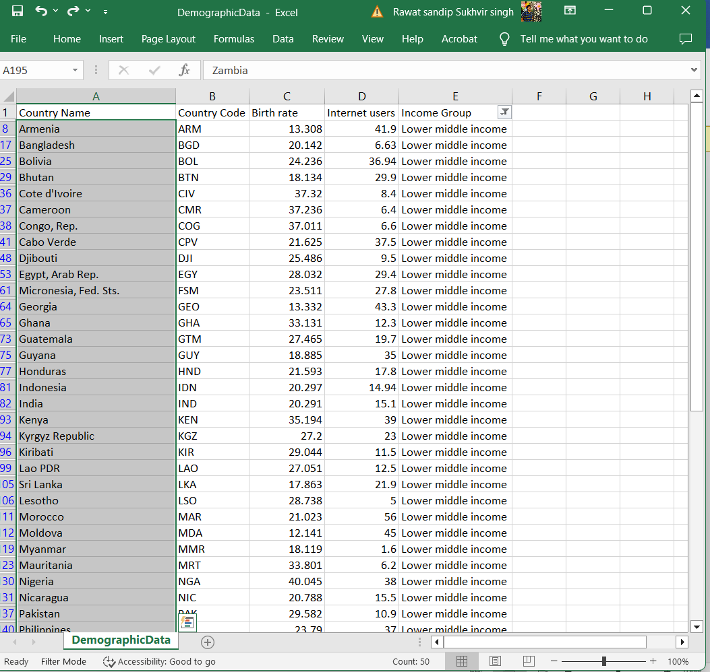

1. Create the pivot table and add country, income group, and internet users in the same Excel sheet.

